# Practical Security Fundamentals

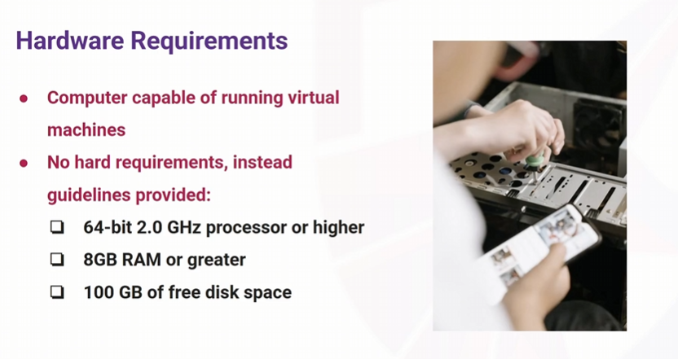

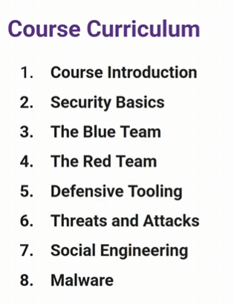

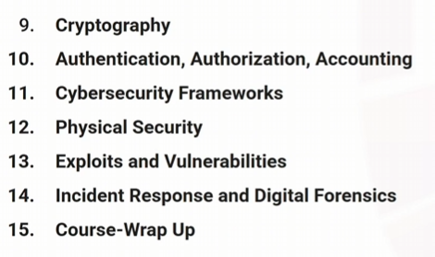

# Security Basics

## Why Security Matters to You?

## Why Security Matters

Instructors’ Answers

- checked my email - were encrypted

- car is connected to internet

- credit card to buy coffee

- signed into computer for work

More technical

- our lives are digital , technology , even social lives

- healthcare , power , clean water

- insecurity is costly (cost to businesses and individuals )

- trust requires security

- its required by law

## The Business of Cybercrime

Cybercrime is a big business - multi-billion dollar industry

Some operate like legitimate business , some are backed by governments

Tools and infrastructure as a service for performing cybercrime

Exploits and vulns sold in black market

How they make money

- ransomware is biggest revenue generator

- selling or extorting stolen data

- business email compromise

Small players add up

- phishing , identity theft and other scams are more common

- more likely target individuals

- provide places to buy , sell and trade stolen data , tools and even criminal training

## THE CIA Triad

Confidentiality , Integrity , Availability - basic model but very integral

# Intro to Blue Team

Blue team are cyber defenders - protecting systems , network and data

Core responsibilities - monitor , detect and respond to incidents , patch management , perform risk assessments , documentation and ticketing , ensure compliance with regulations

## Security Operations Centre (SOC)

Can refer to a physical space

Has become less centralized , it maybe remote , contracted out

SOC comprises of people , tools/tech and processes

Roles of SOC - monitoring , detection , analysis , respond

SOC analyst also referred to as security analyst/engineer

Usually roles tiered like level 1,2,3

Level 1 - for triage of alerts

More complex analysis , investigations and incident response tasks escalated to higher tiers

Use various tools and softwares

Usually work guided by playbooks

## Other Blue team Roles

- Incident Responder

- Security Engineer

- Threat Hunter

- Digital Forensics

# Intro to Red Team

Red team = offensive security

Testing systems by simulating real world attacks

Core Responsibilities

Perform penetration tests , vulnerability scanning

Mimics tools and techniques used by adversaries

Develop tools and exploits

Strictly follow scope , regualtions and laws

Report writing and documentation

Perform client debriefs

Many disciplines for testing different products

## What is Penetration Test

- authorized security test on a system , network or application to identify vulnerabilities

- According to client needs and wants

- usually follow known guidelines , methodologies and frameworks for testing

- frequently performed by external companies or contractors

- end goal to improve overall security

Types of penetration test

- varies based on target

- white box , grey box , black box

- credential / non-credentialed / internal / external

- overt (announced or known) vs Covert (unknown)

Phases of a penetration test

- planning and scoping

- recon and OSINT

- scanning and vulnerability identification

- exploitation

- post exploitation ( repeat 2-5 as needed )

- cleanup

- reporting and debriefing

Penetration testing vs red teaming

- penetration testing and testers are part of the ‘red team’

- Red teaming is a different term

- penetration tests are usually less covert and not concerned with evasion

- red teaming is usually covert and aims to emulate specific adversaries or threats

- uses more complex tactics such as custom tooling or exploits and social engineering

Who’s performing the tests

- penetration tester (ethical hacker )

- have-in-depth knowledge of the systems they test and common vulnerabilities and exploits

- keep up to date with new tools , techniques, exploits ,vulnerabilities and technologies

- write documentation and reports

- communicate with technical and non-technical folks

Other Red Team Roles

- Exploit/ malware developer

- social engineer

- OSINT researcher or investigator

Common pentesting domains

Network , webapp , mobile , application , IoT/Hardware , Industrial Control Systems (ICS), Cloud , AI , Physical/Building

## Red Team Hands on Lab

Docker setup in ubuntu

Attachment - hackme.zip

Sudo apt install nmap

Nmap -p- -A -T4 ip

Lets get started -> login page

We can use hydra and burp suite ( a bit advanced )

Check in the request of the network tab of the f12 and test username and password and enter to get the form data 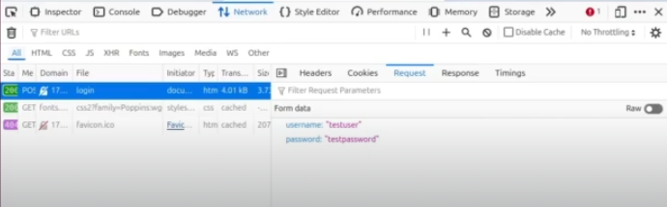

Run this: (dictionary attack)

hydra -l admin -P passwords.txt -f ip -s 5000(port) http-post-form “/login:username=^USER^&password=^PASS^:Login”

we get password as password123

# Defensive Tooling

Vendor neutral - use of free and open source tools throughout the course

## Firewalls

- filter network traffic entering and exiting a network or a computer

- physical or virtual , network or host based

- blocks unwanted or unsafe traffic

- check source and destination IP address , port and protocol

- it filters traffic based on rules in the access control list (ACL)

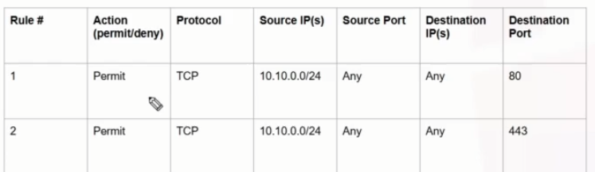

More granular/specific rules should be above in the ACL

Traditional v/s next Gen

Traditional only filter on IP ,port and protocol

Next gen filter on many more factors - user identity and behaviour, threat intelligence , decryption , packet inspection , content filtering

## Firewall Lab

Make it bridged adapter for ubuntu VM

Sudo apt install gedit

Index.html - I am able to see this through firewall

Python3 -m http.server 8080 - check on <http://localhost> 8080

Sudo ufw status

Ip a

Go for host computer to ping back the vm

<http://ip:8080> - thus u can see what we saw in the vm itself as we have no firewall configured

now back to ubuntu vm

sudo ufw enable

sudo ufw status

this leads to the page being blocked on the host machine if tried reloading it

now creating a allow rule

sudo ufw allow 8080/tcp

sudo ufw status

now check back - we are able to see the page as before

now if we create another rule

sudo ufw deny from 192.168.50.93 to any port 8080 proto tcp

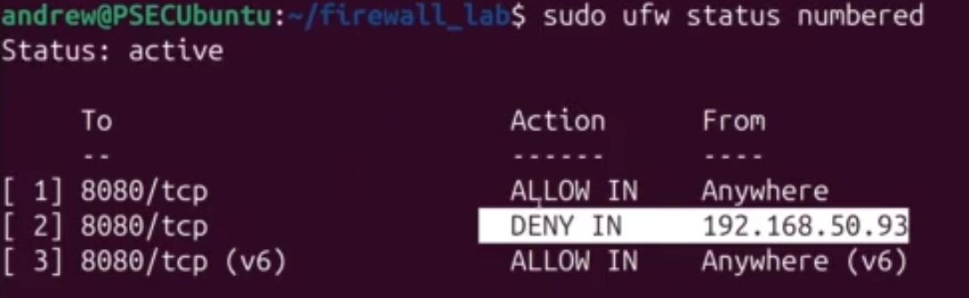

This creates a deny rule below the allow all - well this wont work as supposed as we looked earlier in ACL list

So simply delete the 1st rule and add it at the end

Sudo ufw delete 1

Sudo ufw allow 8080/tcp

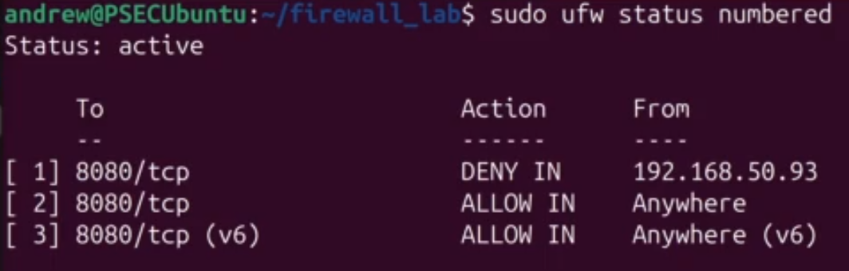

Now get back to the web page - this blocks it as expected

## Intrusion Detection System(IDS) and Intrusion Prevention System(IPS)

IDS - only alerts

IPS - alerts and responds/prevents

Can be host/network based - mostly network based

Network based work by inspecting more properties than what a firewall inspects

Uses signature and sometimes behavioral / anomaly based detections

## Endpoint Protection (AV)

Endpoint - device or node where data enters or leaves a network.

In endpoint protection , software is installed on the device and the device is monitored

Antivirus(AV)

Detect block and quarantine malicious files

Traditionally used signature based detections to check files against lists of known malware/virus

New malware/virus signatures are added to the updated lists used by AV.

Modern also use behavioral techniques to look at malicious behaviour that match to behaviour of other malware

## Signature Based Detection Lab

Malz.zip - made with msfvenom ( create payloads, executables )

Unzip it with the password - infected

Test.exe

Sha256sum test.exe

Md5sum test.exe

Copy the hash and put over virustotal

## Endpoint Protection

Significant more advanced and capable from of endpoint protection

Relies on multiple different sources of data ( telemetry) to proactively detect and respond to threats

e.g telemetry - file signatures , network connections , memory ,kernel systems or API calls what files are accessed or opened

telemetry is collected by a piece of software referred to as an agent which is installed on endpoints

key takeway - advanced threat detection that collects telemetry from endpoints and uses that to determine and block threats

## SIEM

Collects and aggregates logs from sources and tools like firewalls , IDS/IPS , EDR , logs from services, cloud tools , threat intel

Can be used for threat hunting and in-depth log analysis

SOC 101 course

## Defense in-Depth

No security tool or control is perfect

Provides redundancy in case of complete control failure

Attackers are frequently looking for easiest target - multiple defenses is a deterrent

Confusion matrix

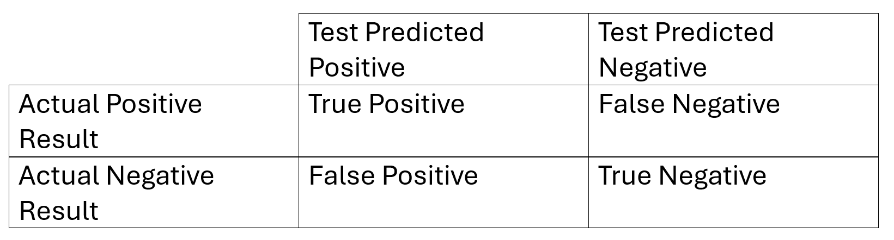

# Vulnerabilities v/s Exploits

Vulnerability - weakness or misconfiguration in software , hardware , processes , physical design that can cause unintended behaviour

Exploit - method in which a vulnerability is taken advantage the un-intended behaviour

This can include - software attacks , plans that take advantage of gaps in processes , targeting systems with default credentials

Chain of Events

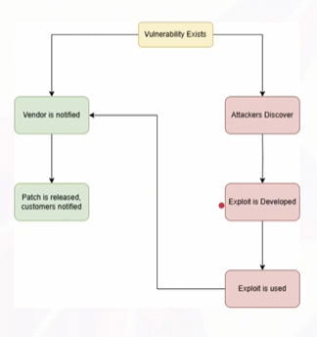

When a vulnerability is disclosed and or exploited before a vendor knows about it this is referred to as a zero-day (0-day)

Existence of a vuln doesn’t mean there is an exploit

Some exploits are made public as proof of concept (POC)

e.g. unintended behaviour - Remote code execution , privilege escalation , info disclosure , unauthorized data access , denial of service

## Exploit Lab

Unzip the provided rootme.zip

We see - exploit , exploit.py , Makefile , rootme.c

Sudo apt install build-essential

Gedit Makefile

Make all

./rootme

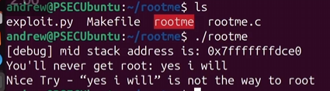

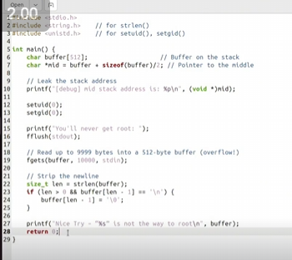

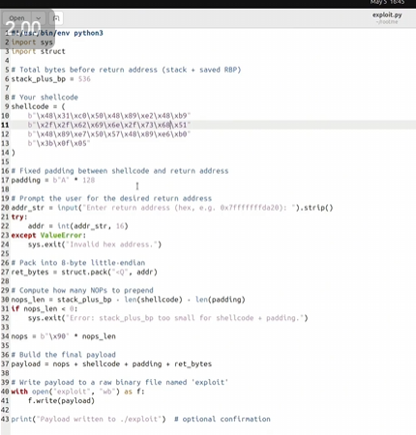

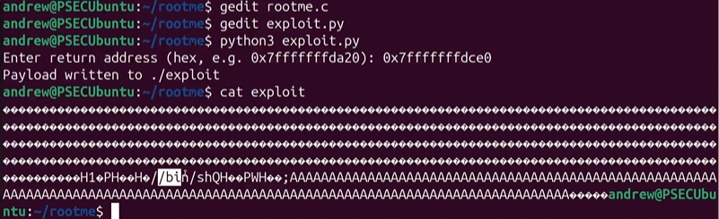

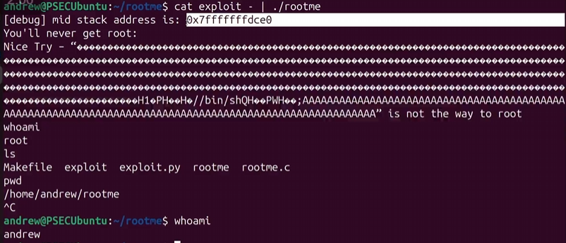

## CVE,CVSS,CWE

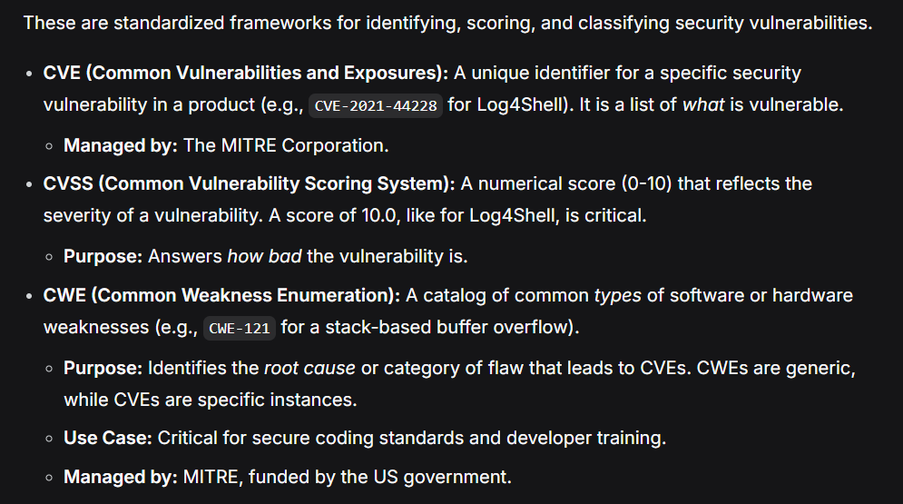

# Intro to Threats and Attacks

Threat Actor - individual / group or org that conducts malicious cyber activity

Diff types of threat actors or groups have different motivations , targets and TTPs

What,why and how of threat actors actions

Tactics

Techniques

Procedures

TTPs map well to the MITRE ATT&CK framework

Cybercriminals

Financially motivated - ransomware , credit-card fraud , extortion , sale of data

Most common type of threat actor that the majority of organization will need to defend against

Common TTPs include phishing , buying access, leaked credentials , exploitation public facing applications , powershell scripts and publicly available tools

Hactivists

Ideologically or politically motivated

Common TTPs include defacing of websites , destruction of data , leaking of confidential materials , denial of service (DoS,DDoS)

Script Kiddies

- individual /groups use readily available tools/exploits

- usually motivated by thrill seeking , peer recognition , curiosity

Common TTPs include publicly available tools and exploits like nmap , Metasploit , LOIC , POCs of exploits

Insider Threats

- individuals inside of an organization who either aid or perform cybercrime

- it could deliberate in their action , or negligent who are well intentioned but careless

- motivations - financial , revenge , and ideological

- common TTPs include selling of credentials , executing malware , exfiltrating files or data

Nation State Actors / APTs

- govt sponsored or operated groups

- possess substancial resources , highly trained and skilled personnel , and the resources to conduct long engagements

- motivation - espionage , intelligence gathering , strategic sabotage , propaganda , cyber warfare

- TTPs include custom malware and exploits , 0-days , compromising supply chains , sophisticated phishing campaigns

Cyber crime groups : Conti,Lockbit,Revil , BlackCat

Hactivists groups : anonymous and LulzSec

Nation State Groups include : APT28 , APT38 , APT10

## Network Based Attacks

Attack that targets the communications on a network between systems , rather than the systems themselves

Large blast radius

Impact on CIA

C: eavesdropping

I: tampering with data in transit , impersonation

A: flooding networks to knock them offline (DDoS)

Network recon , scanning and enumeration

- frequently cyber attacks begin with the recon , scanning and enumeration of the network itself

- passive(only observing network traffic) and active recon(port scanning , service identification and vulnerability scanning )

- common tool - nmap

Common Network-Based Attacks

- eavesdropping and sniffing

- spoofing

- man in the middle (MITM)

- denial of service

Common Network-Based Defenses

- network monitoring tools such as IDS/IPS

- filtering tools such as firewalls

- encryption of data in transit using TLS/SSL

- segmentation of network traffic through the use of subnets and VLANs

- rate limiting services such as cloudflare or other anti-ddos tools

## Packet Sniffing Lab

Ubuntu vm

Sudo apt install wireshark

Wireshark --version

Sudo wireshark

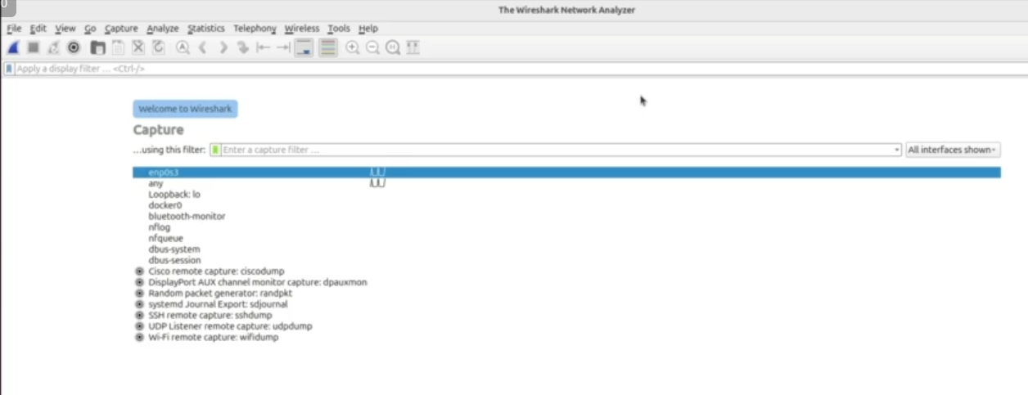

Sudo docker compose up

Copy the local address

Select loopback

Go to the ip address

And input username and password

Stop in wireshark

See for post request

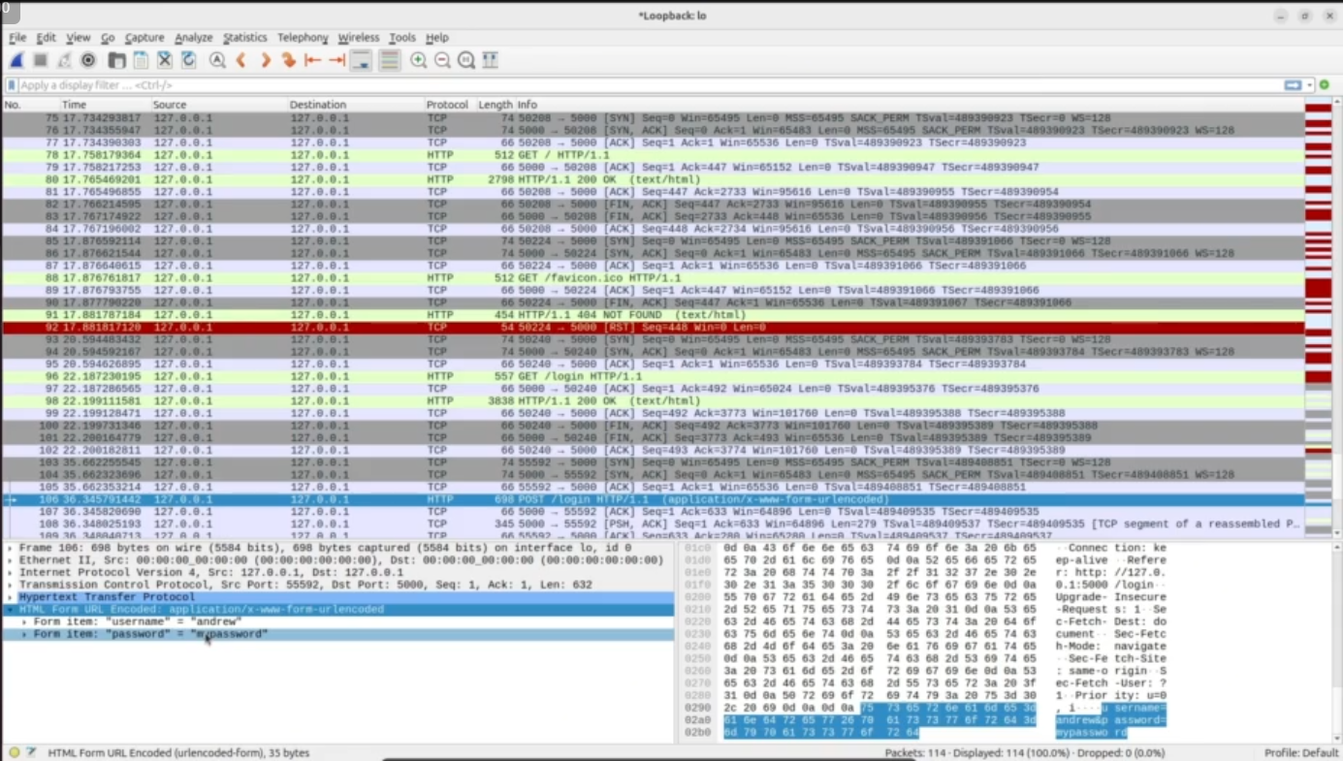

You can see the username and password in plaintext as it was http

## Wireless Attacks

Wireless protocols a lot in use

e.g. WiFi (802.11x), cellular(4g,LTE,5g, etc ), Bluetooth , LoRa , NFC

wireless attacks and defense share overlaps with network-based attacks (e.g. packet sniffing )

- properties of wireless networks present new attack vectors and methods

WiFi Protocols

3 common protocols - WEP , WPA/WPA PSK , WPA/WPA2 Enterprise

- WEP is deprecated and should never be used , it is easily crackable

- WPA/WPA2 use PSK = Pre-Shared Key -> one password top access network

And Enterprise = per-user credentials , uses an additional server for authentication

WiFi Attacks

Packet sniffing

Deauth/disassociation attacks

Key recovery and cracking attacks

Rogue access points/Evil-Twin APs

Wireless MITM attacks

Attacks on RF frequencies such as jamming

Wifi defenses and mitigations

- enforcing and using secure protocols (WPA2, WPA3)

- using strong paraphrases if using PSKs

- use of network defensive tools such as firewall , IDS/IPS

- network segmentation and use of guest wireless networks

- using encrypted protocols (https)

## Supply-Chain Attacks

Adversaries target vendors , tools or components that an organization depend upon

Compromised elements are then supplied to org through legitimate methods

Downstream systems and customers are impacted

Common vectors for supply chain attacks

- third party softwares libraries , especially open source

- build tool and tool chains / hardware and firmware

- services such as managed service providers (MSPs)

Defense and mitigations

- use of software bill of materials (SBOMs) to track dependencies

- scanning and review of vendor tools and libraries

- code review / scanning tools

- audits and risk assessments

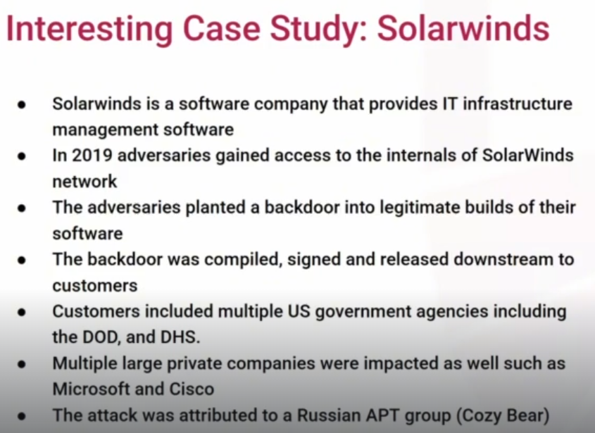

## Physical Attacks

Exploiting physical access or proximity to compromise assets , can cover hardware hacking

Types of physical attacks

- unauthorized entry

- physical network access

- physical component access

- dumpster diving/ improper device disposal

Defense against physical attacks

- layered access controls such as fences ,camera , badge access , access logs

- use and review of access logs

- internal policies - visitor escorts , badges , clean desk policy , proper device disposal

- employee training on suspicious behaviour

- physical security audits

**Lockheed Martin Cyber Kill Chain** and the **MITRE ATT&CK Framework**

**Key Differences at a Glance**

| Feature | Cyber Kill Chain | MITRE ATT&CK Framework |
| --- | --- | --- |
| **Structure** | Linear, 7-stage process | Matrix-based, non-linear |
| **Focus** | High-level attack lifecycle | Granular, real-world techniques |
| **Primary Use** | Strategic defense planning and incident analysis | Tactical detection, threat hunting, and testing |

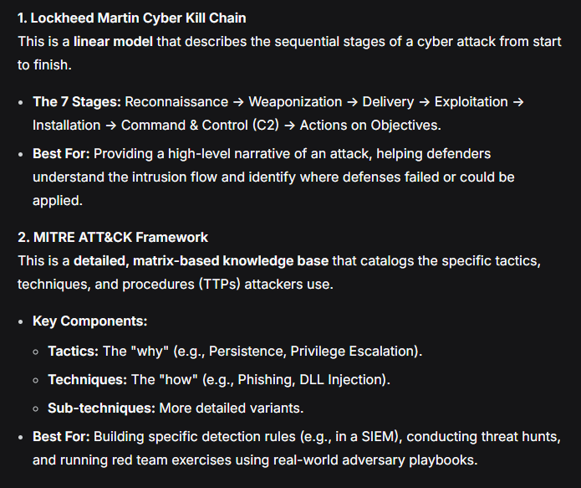

In practice, the **Kill Chain** is often used to explain *how an attack happened*, while **ATT&CK** is used to define *what exactly the attacker did* and how to detect or simulate those specific actions.

# Social Engineering

Act of manipulating someone to do something

Giving up password , confidential info , clicking a link or even letting someone into a building

One of the most successful and common avenues for threat actors to gain initial access into an organization

## Phishing

Type of social engineering - attackers attempt to solicit info or have a user perform an action via different mediums

Common goals - gathering passwords/ credit card details through fake portals

- getting users to click links to malicious websites

- getting users to download malicious attachments

- gathering confidential info

Smishing = sms phishing

vishing = voice phishing

Spear phishing = targeted phishing attempts

whaling = targeting high value accounts like C-Suite (CEO,CISO,CFO etc)

## Tailgating and Impersonation

Tailgating

- attackers attempt to follow a person in through a door or access point

- sneaking in behind them before door closes or using a pretext to get the person to hold the door or open it for them , used to gain access to building or areas that are restricted

Impersonation

- attackers impersonate others either through disguises , fake badge , or pretexts

- impersonation is frequently combines with other types of social engineering

## Social Engineering Defenses

Social engineering attacks target people

Employees are the first line of defenses

Imp to create a security culture - security awareness training , phishing siumulations , clear reporting instructions

- proper verification procedures (requiring multiple sign-offs, out of band checks )

- least privilege

- visitor policies and escorting requirements

Technical controls

- email defenses (blocking known malicious domains , URL and attachment scanning )

- multi-factor authentication

- other common defensive tooling such as EDR,IDS,Firewall

# Malware

Software created to cause harm to a device , network , system or user

Such as - steal info , extort money , spy on users , gain unauthorized access , disrupt operations

Malware can take many forms - email attachments , documents , USB drives , hijacked softwares

- one of largest cyber threats to orgs , it is costly and disruptive

Virus

One of the original forms of malware

- malicious code that attaches or inserts itself to files or programs

- spreads through some form of human interaction to infect , like opening attachment or running a program

- frequently perform file deletion ,data corruption or resource consumption

Famous example - Stuxnet - targeted the Iranian nuclear program , using infected USB devices

Worms

Self replicating malwre that can spread without any human interaction

- usually spread using a known vuln or leaked/weak credentials

- usually designed to deliver a payload such as a remote connection or ransomware

Famous example - WannaCry - used EternalBlue exploit to spread , delivering ransomware

Trojans

Malware disguised as legitimate software

- users will legitimately download and install or execute thinking it is not harmful (fake games , cracked software , songs or other media )

- designed to deliver a payload such as a remote connection ,credential stealer or other malware

RAT = remote access trojan

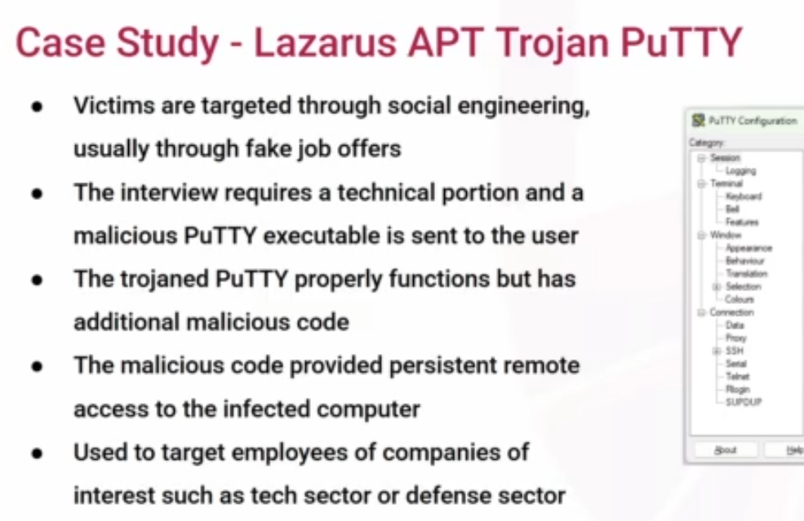

## Ransomware

- type of malware designed to encrypt data or lock access to a system until a ransom is paid

- widespread multi-dollar cybercrime industry

- one of the most disruptive threat to orgs face

Ransomware lifecycle

- gain initial access to an org through - phishing , known exploits, buying credentials

- they use the initial access to pivot and compromise as many or all resources as possible

- ransomware is then deployed to compromised systems which encrypts file and/or systems

- ransom note is displayed with a demand for payment and details on how to pay ( mostly via cryptocurrency )

- frequently orgs will pay and receive the decryption key , but there is no guarantees

Types of Ransomware

Crypto ransomware : encrypts the files and data on a system , but not the system itself (wannacry)

Locker ransomware : locks the entire system so it cannot be used at all (WinLocker)

Double Extortion Ransomware : Exfiltrates sensitive data before encryption to be used for further extortion

Ransomware-as-a-service (RaaS) : ransomware malware and infrastructure is sold or leased to affiliates e.g. initial access brokers

To Pay or Not to Pay

- Law enforcements and govt recommends not paying ransom

- if everyone stopped the act of asking ransom would stop , but today most orgs pay ransom

- ransom demands are usually lower that the operational costs of recovering

- there can be legal implication for paying ransom to sanctioned countries or groups

## Spyware and keyloggers

Spywares

- designed to secretly monitor and collect user activity and data (keystrokes , browsing data , screen captures , exfiltrate data , emails , instant messaging )

- designed to go undercover and run silently in background for as long as possible

- harvest credentials , gather intel for blackmail or fraud

- corporate or nation state level espionage

-Famous example - Pegasus

Keyloggers

- specific type of spyware that only captures keystrokes

- less complex , easier to hide and can operate in hardware, browsers , software and even kernel

- also usually delivered as a payload of other malware

- can be delivered via a USB plugged into a computer

## Rootkits

- stealthy type of malware designed to evade detection and give attackers privileged access to a system

- rootkits are usually a collection of tools that are designed to hide the existence of malware and its activity on a system

- due to its low level operating , access detection is challenging , some rootkits even modify the reporting of the OS itself

- it can even persist reboots and fresh installs to the computer

- usually used in advanced high value targeted attacks that require lengthy engagement windows

Types of Rootkits

- user-mode: installs in user space and usually replaces system level binaries (e.g. ls , ps )

- kernel-mode : operates at the OS kernel level

- bootkits : infects the bootloader

- firmware : resides in hardware firmware (BIOS , network bards )

## Maldocs

- malicious documents

- legitimate document formats that are embedded with malicious code , links or exploits

Most commonly used document formats for maldocs - word(.doc,.docx),excel(.xl,.xls),PDF

- frequently used in phishing emails as attachments

How do maldocs work ?

- usually begin with social engineering

- frequently will use a .docx, .xls , .pdf where the user is prompted to enable macros (disabled by default)

- document then runs embedded scripts through VBA (visual basic for Applications ) for office docs and Javascript for PDF

- malicious scripts download and execute a payload

- maldocs exploit vuln in the processing software itself e.g Foxit PDF CVE-2020-14425

## Static Malware Analysis Lab

Static analysis is performed without executing the malware target being analyzed

- using tools to identify parts of file/details , looking for readable strings , static reverse engineering , calculating hashes

Dynamic Analysis is performed while executing and running the target malware

- looking at network traffic , files created/accessed , processes created , using debugging tools

For the lab

Checking the same malz.zip which when extracted gave test.exe

file test.txt



Sha256sum test.exe



Md5sum test.exe - to take notes



Hexdump

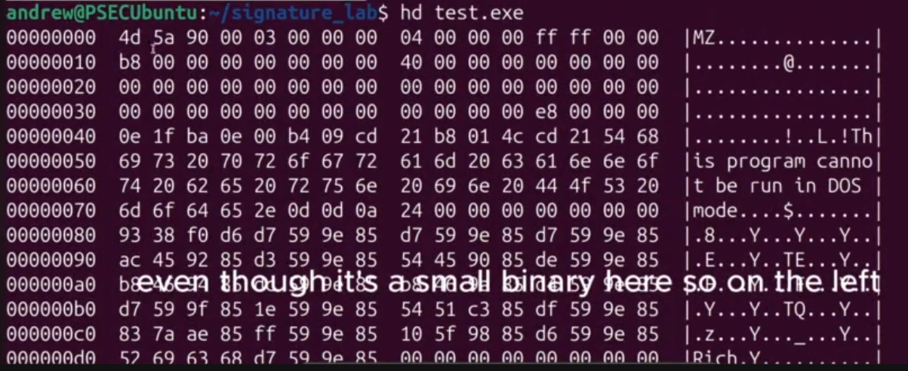

Strings test.exe

Strings -n6 / -n8 test.exe - sometimes to get rid of non actual strings

Strings test.exe | grep “http”

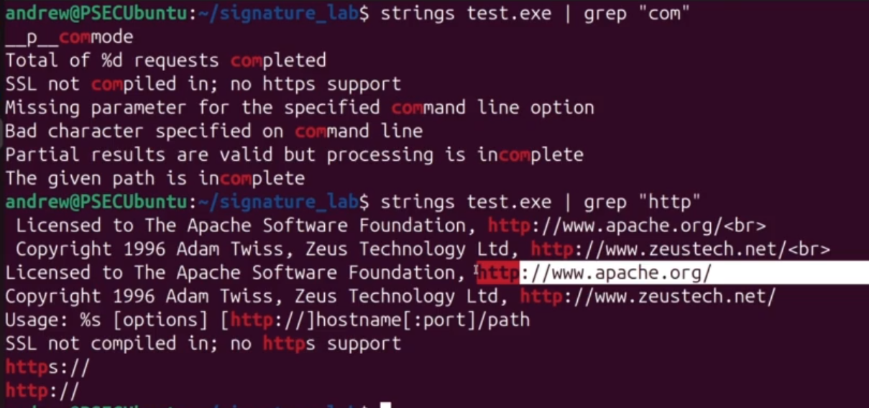

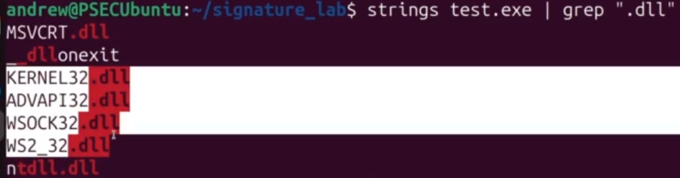

Windows api calls - it could be legitimate but also could be harmful

**Payload:**the part of the malicious code that performs the harmful action. For example stealing data, or connecting to a server.

**Shell:**program or part of program that allows an attacker to execute commands on a system. The most common type of network shell is a **Reverse Shell** where the shell connection originates from the infected target and connects back to the attacker.

**Botnet:**A network of compromised machines controlled by an attacker, the compromised machines are sometimes referred to as **Zombies.**

**Backdoor:**Hidden access point into a system, could be put there by developers or via supply chain attacks

**Dropper:**Malware whose main purpose is to install other malicious files onto the system.

**Command and Control (C2): I**nfrastructure that malware communicates with to receive instructions.

**Obfuscation:**Techniques that make malware code harder to detect and/or analyze.

**Logic Bomb:**Malicious code that is triggered when a specific condition is met, for example an employee is let go from a company.

**Adware/Bloatware:**Displays unwanted ads or has unwanted functionality. Often is bundled in with other legitimate software.

**Scareware:**Malware that tricks users into thinking they have an infection in order to sell fraudulent or fake solutions.

**Persistence:**Refers to a malwares ability to survive system reboots.

**Cryptominer:**A type of malware or payload of malware that uses the infected systems computing resources to mine cryptocurrency.

# Cryptography

Cryptography - science of securing data through encoding

Essential for confidentiality and integrity

Cryptography is a pillar of modern cybersecurity

Cryptography in History

- Caesar Cipher = substitution cipher

- enigma cipher = create extremely complex substitution ciphers

- Navajo Code Talkers: spoken code based on Navajo Language used by US military

Everyday Cryptography

- used extensively in web browsing to keep our connections secure through HTTPS

(encryption of data in transit , ensuring a website is who they say they are )

- used in most communication applications ( whatsapp , signal , telegram )

- used to sign software , applications , documents and more

## Encryption

Encryption : converting plaintext into ciphertext to protect it from unauthorized access

Plaintext: original human ( or machine ) readable data

Ciphertext: encrypted unreadable version of data

Key : a secret value used to encrypt / decrypt the data

Initialization Vector (IV) : random non-secret value used during encryption so that the same plaintext produces different ciphertext

Algorithm : the formula used for encryption / decryption

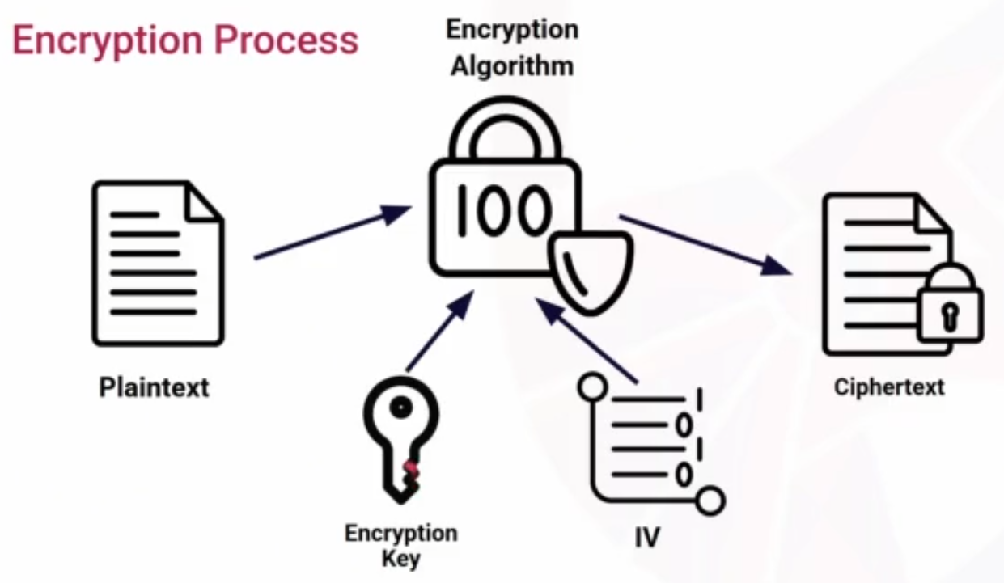

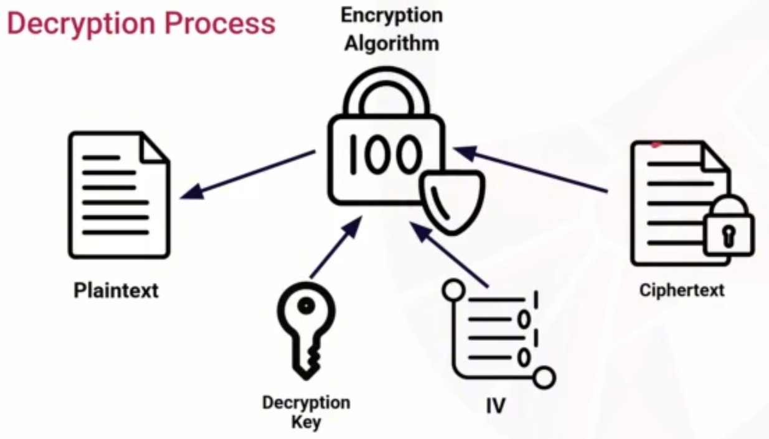

Same key for encryption and decryption = Symmetric Encryption

One key for encryption , other for decryption = asymmetric encryption

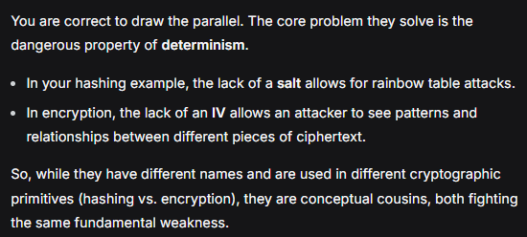

Symmetric Encryption

- one shared key for encryption and decryption ( should be private )

- faster encryption and decryption than asymmetric

- great for large amount of data

- secure key distribution is a challenge

Asymmetric Encryption

- uses two keys - one for encryption and other for decryption

- slower than symmetric

- Encryption Key : Public/ Shared Key

- Decryption Key : Private/ Secret Key

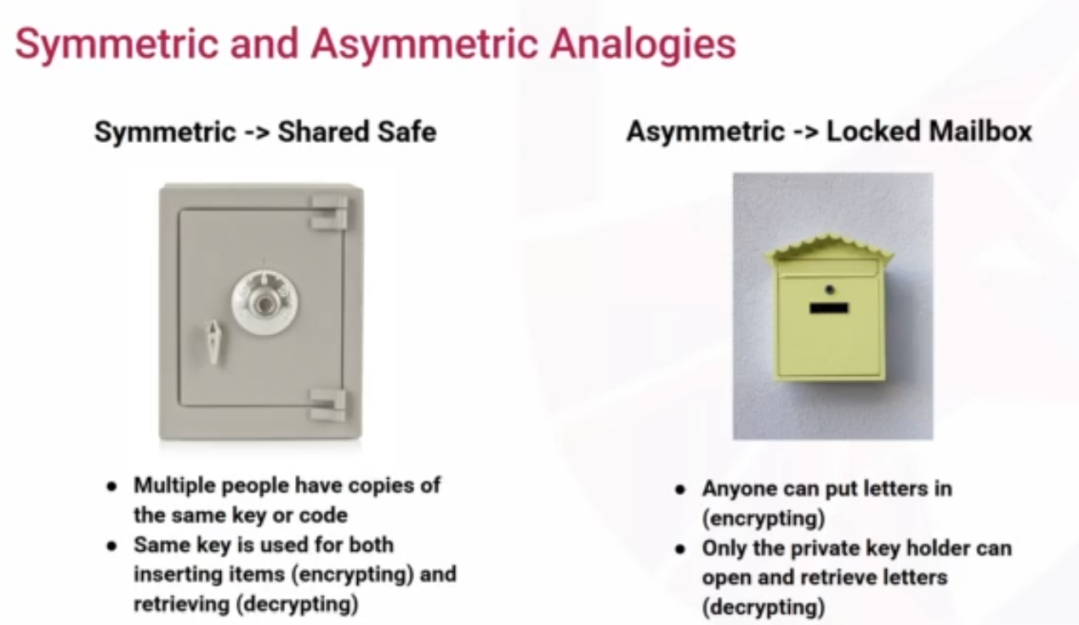

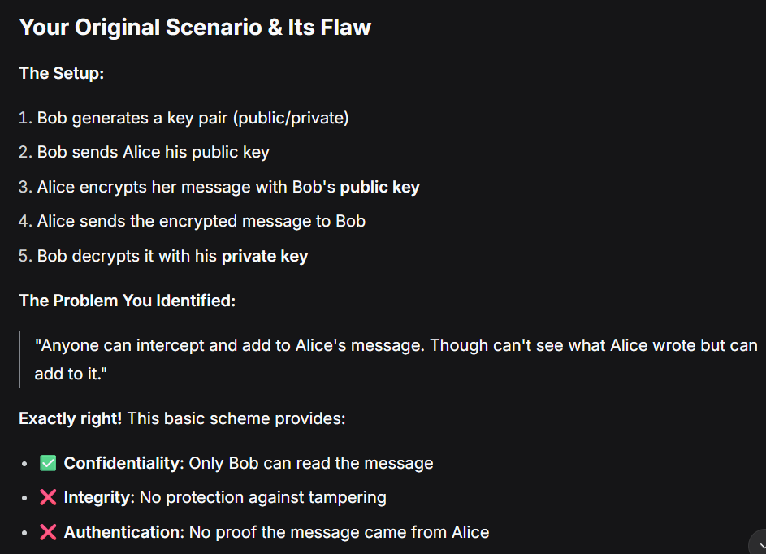

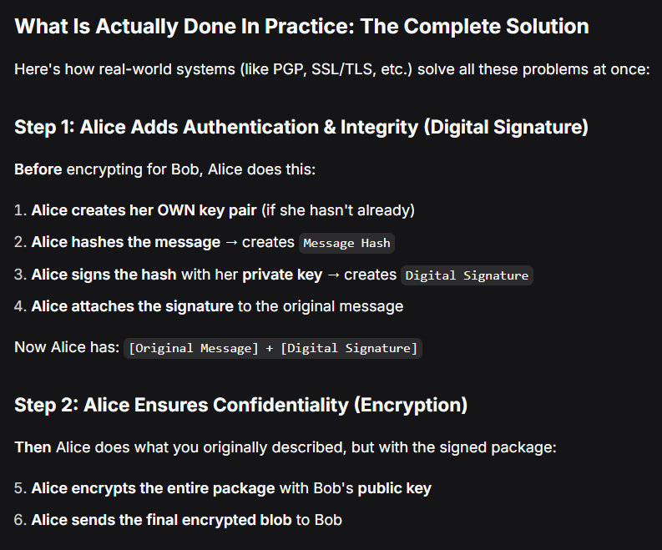

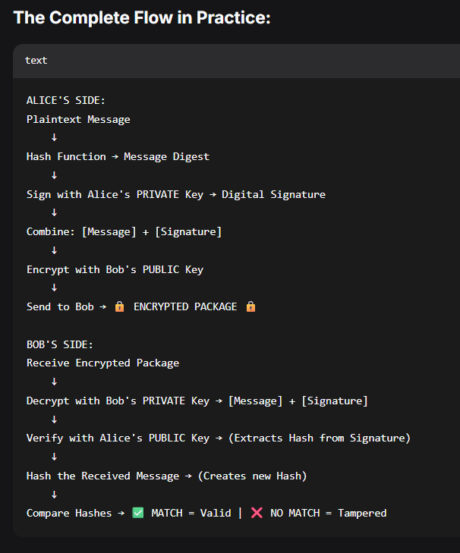

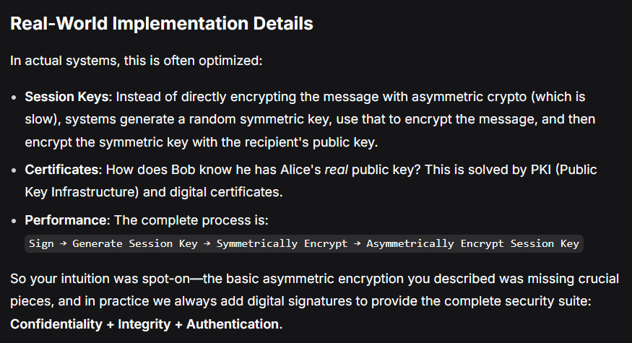

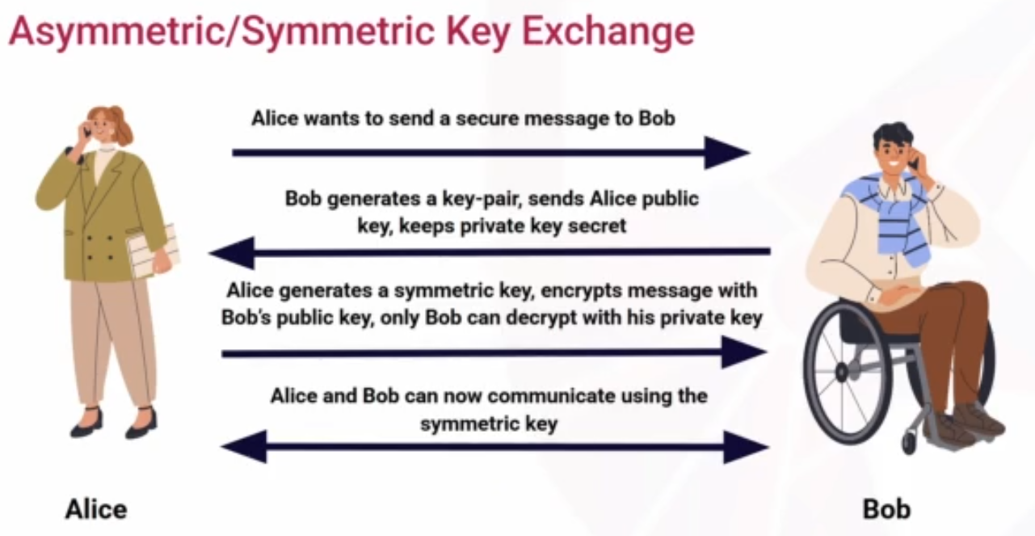

## Hashing

One way cryptographic function converts data into non-reversible fixed-length output

Hash/digest : output of a hash function

Deterministic : the input will always give the same output

Non-reversible : there is no way to decrypt a hash

Collision-resistance : no two different inputs give the same output

- hashes are very fast to compute

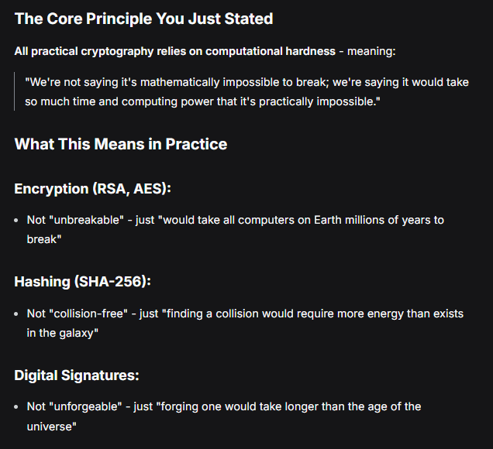

Use cases for hashing

- password storage - sometimes some salting required to make brute force much harder

- integrity verification

- digital signatures

## Digital Signature

- cryptographic method that proves both authenticity and integrity of message or file

Uses both hashing and asymmetric encryption

Hash - used for integrity

Encryption - used for authentication proving the message came from the private key holder

- provides non-repudiation

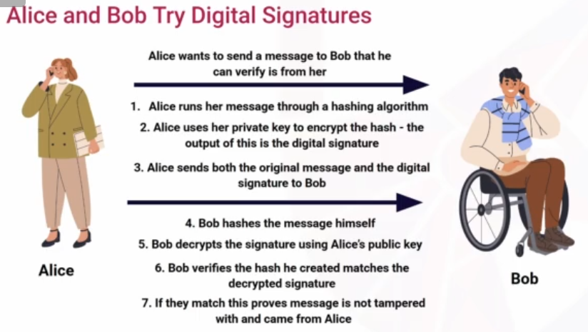

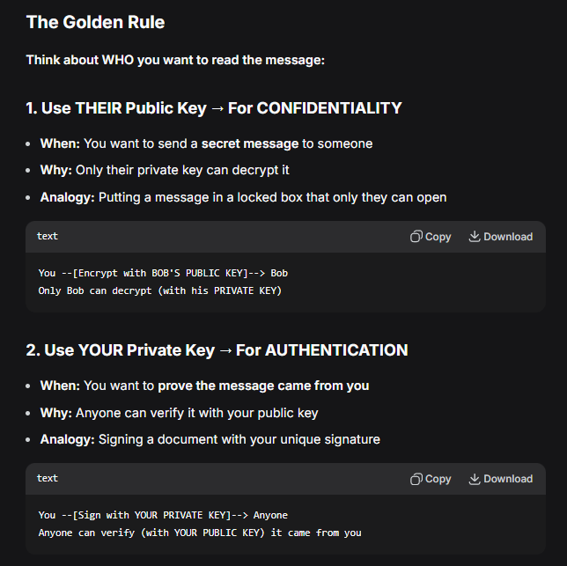

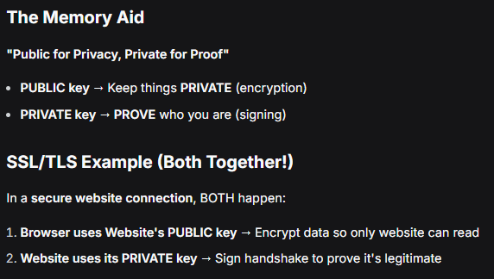

Analogy

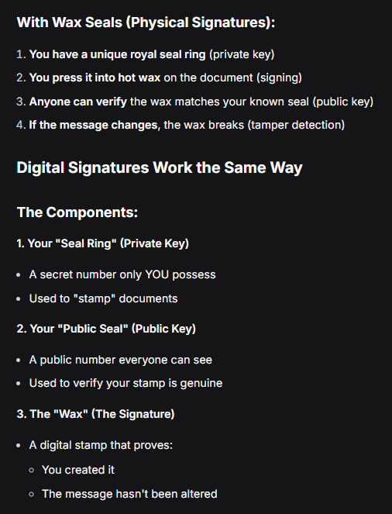

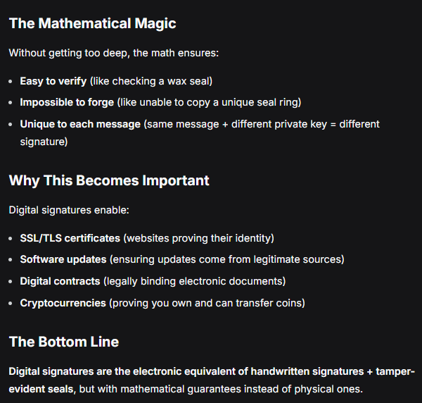

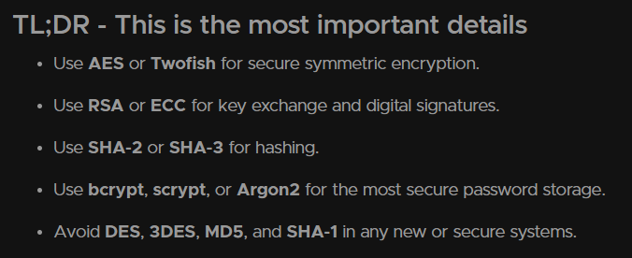

## CyberChef Lab

Using cyberchef and try different symm and asymm encryptions

## Certificates and Public Key Infrastructure

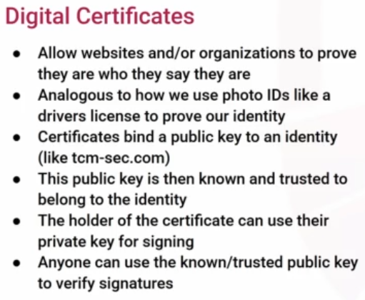

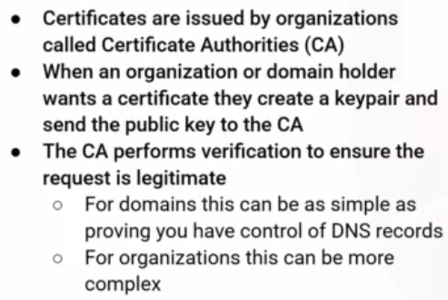

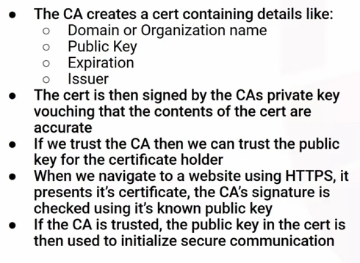

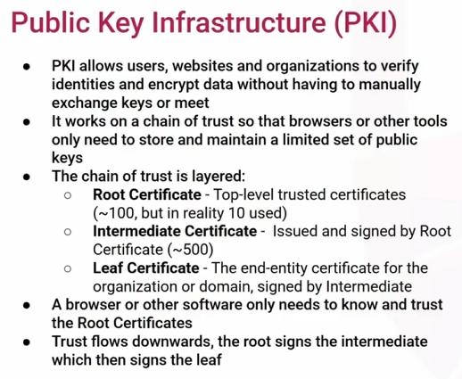

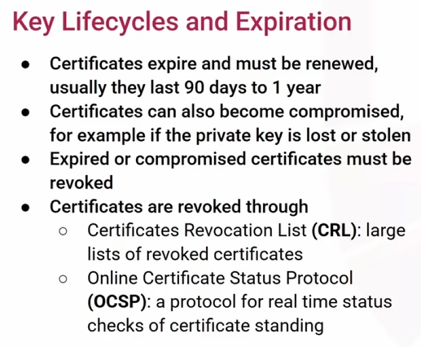

## HTTPS, TLS and SSL

- HTTP = Hypertext Transfer Protocol

- Protocol used for web browsers to communicate with servers

- Data is sent as plain text

- No assurance the data you receive is from the domain you’re visiting

- Vulnerable to MITM , sniffing and other attacks

HTTPS = secure version of protocol

- it uses TLS to enhance security

- connections are encrypted , authenticated and integrity-protected

- HTTPS does NOT mean a website is safe

- it only provides domain authenticity

- it only says that data send has not been tampered

- it only encrypts data in transit

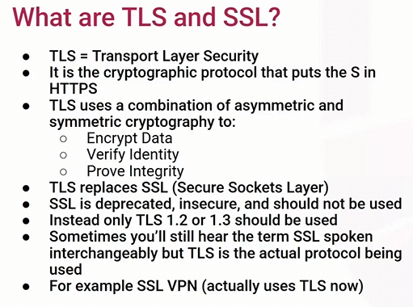

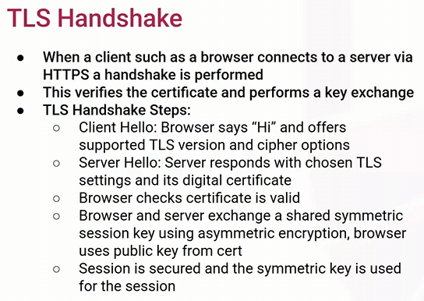

## Common Cryptographic Attacks

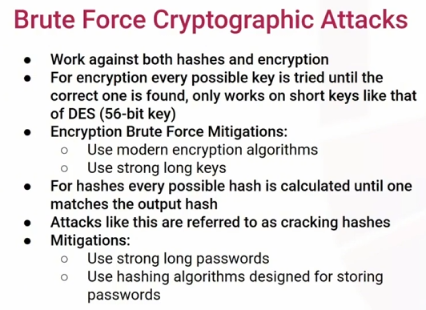

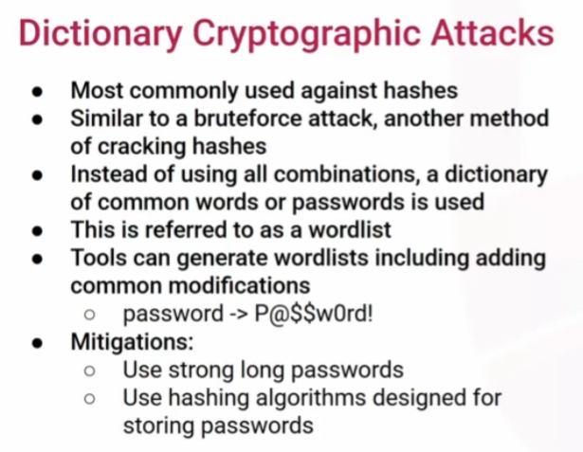

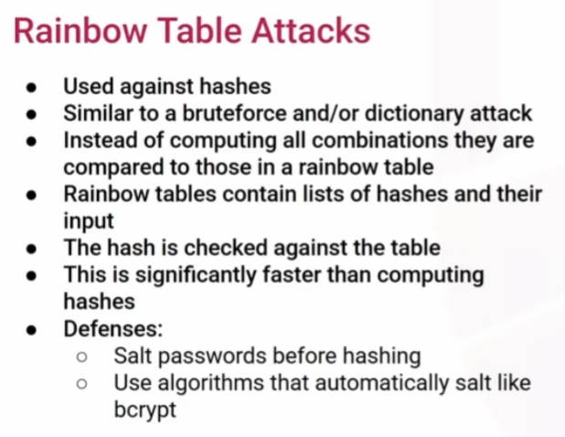

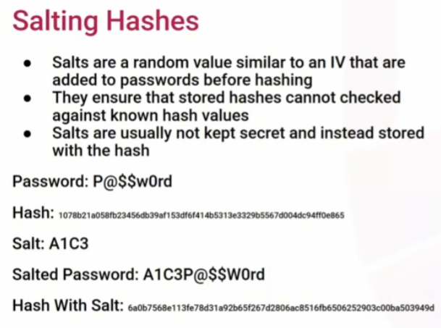

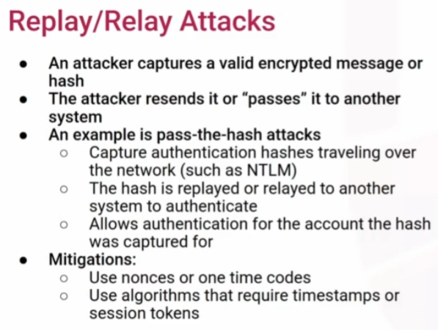

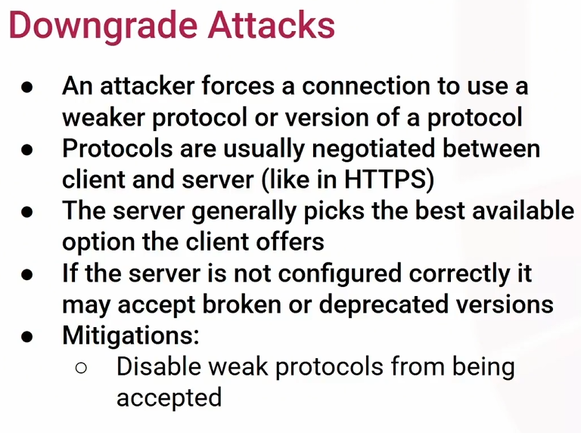

## Hashcat Lab

Sudo apt install hashcat -y

In other terminal

Sudo su root

Cd /etc

Cat shadow

Copy this

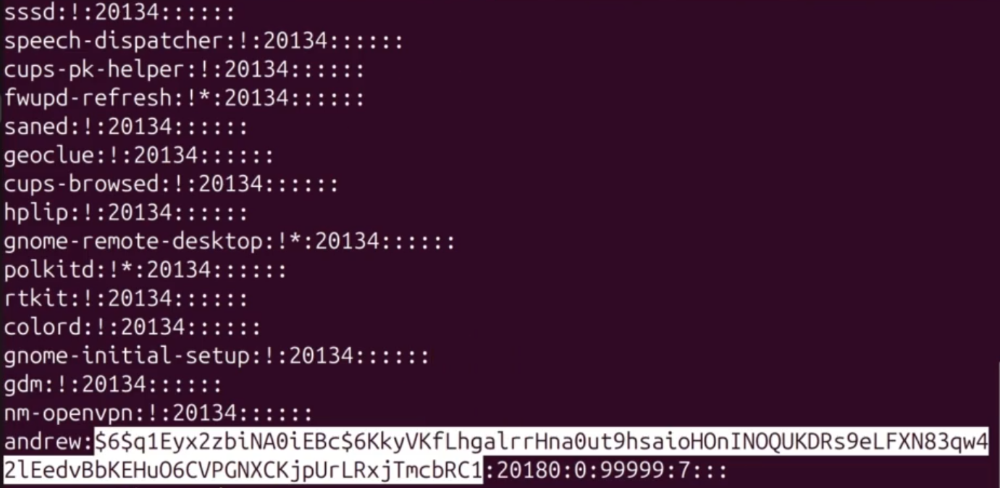

Using wordlist.txt from crackme.zip to run the attack

Gedit hash.txt and paste the hash and save it

Hashcat -h | grep “\$6”

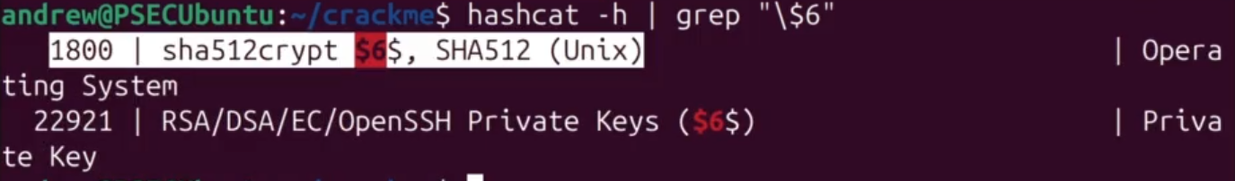



-m 1800 = mode from above for sha512

-a 0 = dictionary attack

cracked.txt = to store the cracked password

--force = to do all the computations on CPU as we are on vm

--potfile-disable = to create a rainbow table for itself so it does not do computation each time



# Authentication, Authorization and Accounting (AAA)

Foundational security concepts governing

- how users access systems/data

- who can access systems/data

- how activities are monitored

Integral for - access control , regulatory compliance , supporting investigations , reporting

Authentication - verifying identity

Common methods - passwords, PINs, fingerprints , IDs , smartcard

Authorization - what is allowed to access

Control access to files/data , systems , commands , tools/software , areas or rooms

Accounting - tracking user activities

Common accounting items : login details , files accessed , resources accessed , physical entry to offices/rooms

Config changes

Commands entered

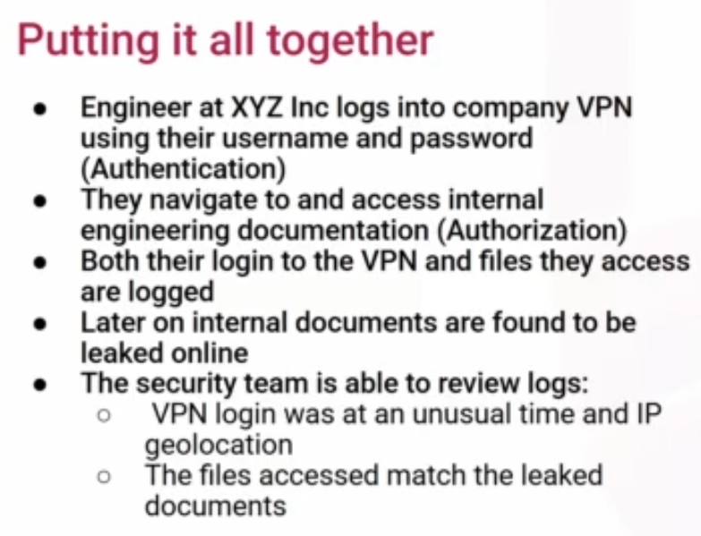

## Least Privilege

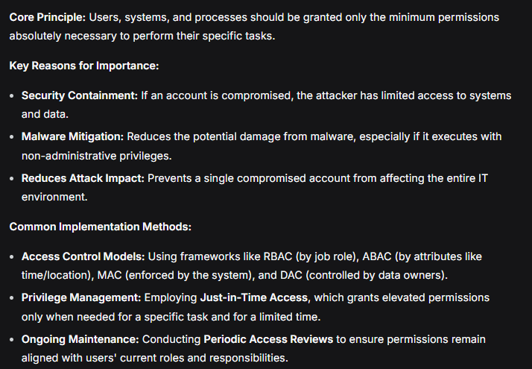

## Identity Access Management (IAM)

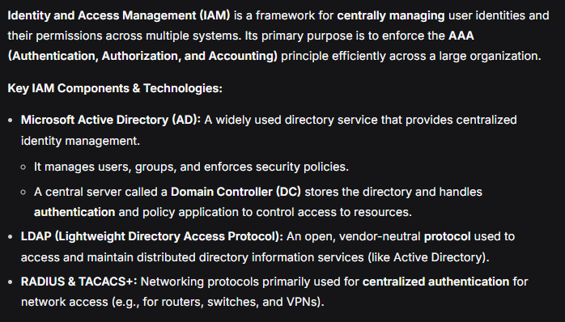

In summary, while both are AAA protocols, you would typically use **RADIUS for general user access** to the network and **TACACS+ for controlling and auditing administrator access to network infrastructure**.

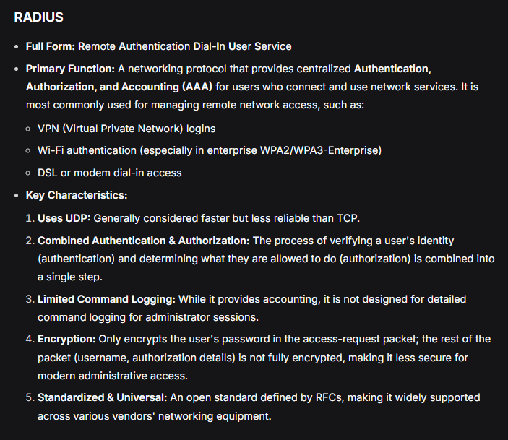

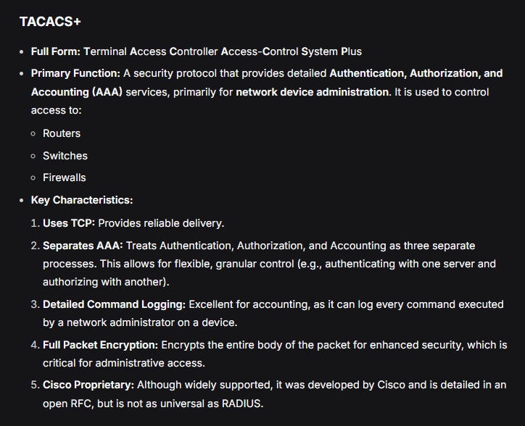

## SSO and MFA

SSO

- authenticate solution that aggregates access to multiple applications or systems in one-place

- this allows them to access applications and systems they have access to

- frequently a lot of them are cloud based solutions

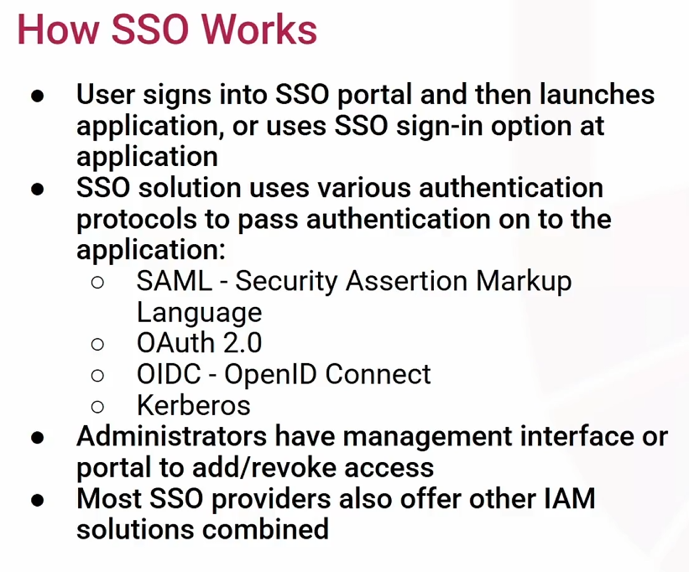

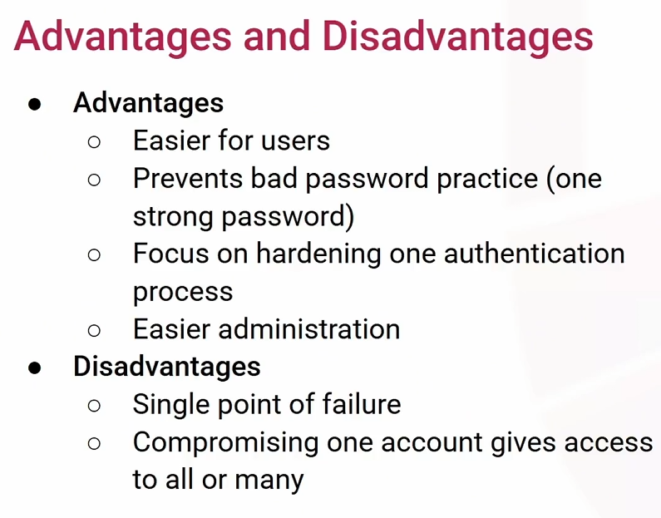

Multi-Factor Authentication (MFA)

- authentication requires 2 or more factors to successfully authenticate.

- factors include = something you know , have , are

- most common combination is password + token generated through MFA app on phone or text message

- using 2 of same factor is NOT MFA (e.g. password + security question )- both are ‘you know’

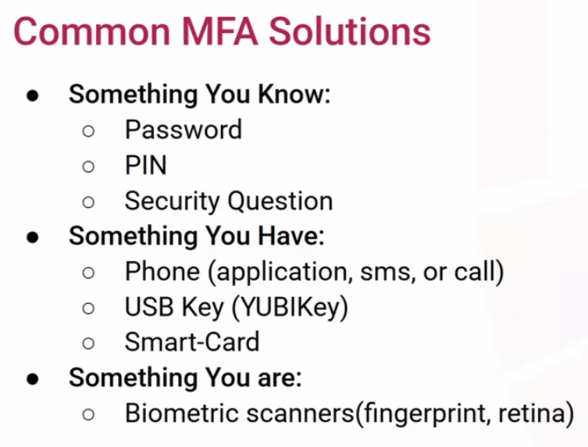

## Linux AAA lab

Sudo adduser heath

Enter password - like simple one

Full name: Heath Adams , and skip rest details

Y to confirm info correct

Sudo su root

Cd /etc

Cat shadow



Exit - to exit out of the root shell

Su heath , enter password

Cd ..

Ls

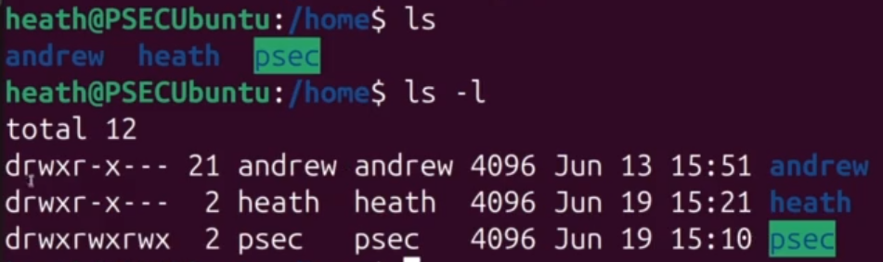

Su Andrew

Chmod 777 heath

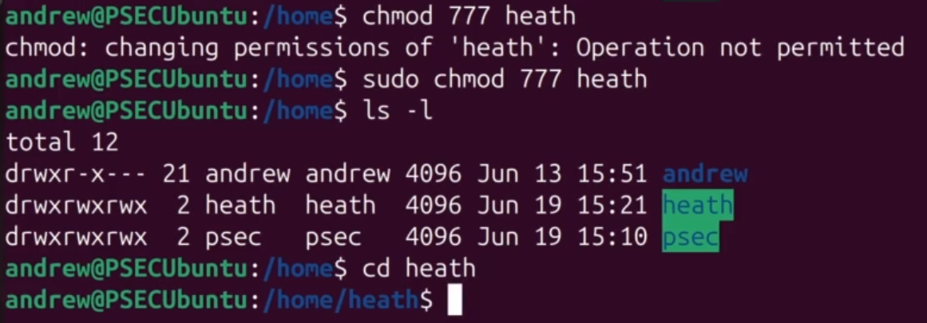

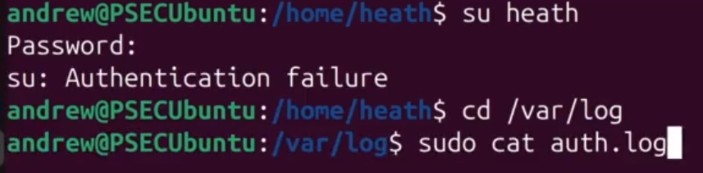

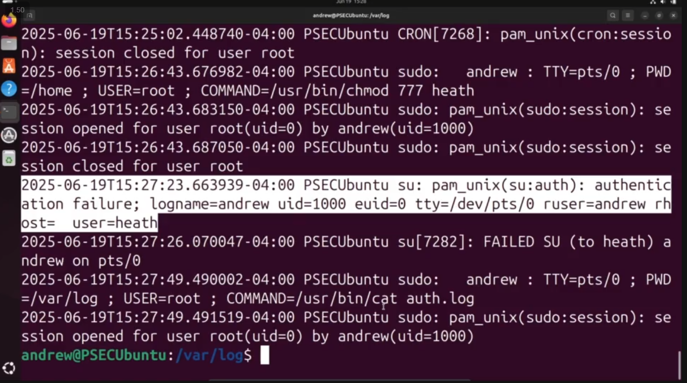

# Security Frameworks, Standards and Regulations

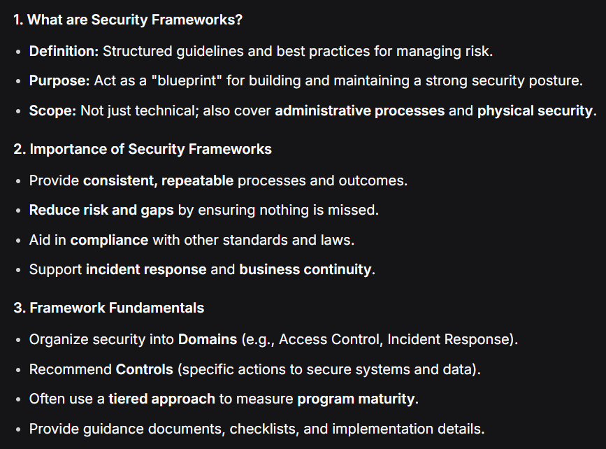

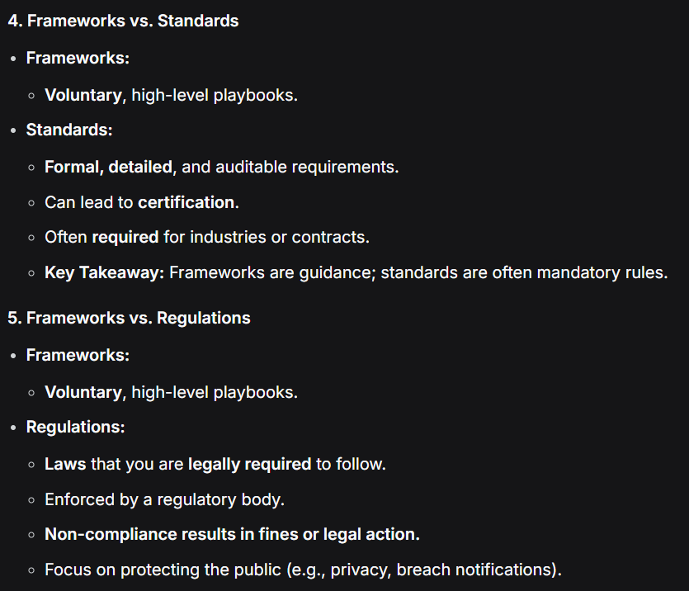

## Risks and Control

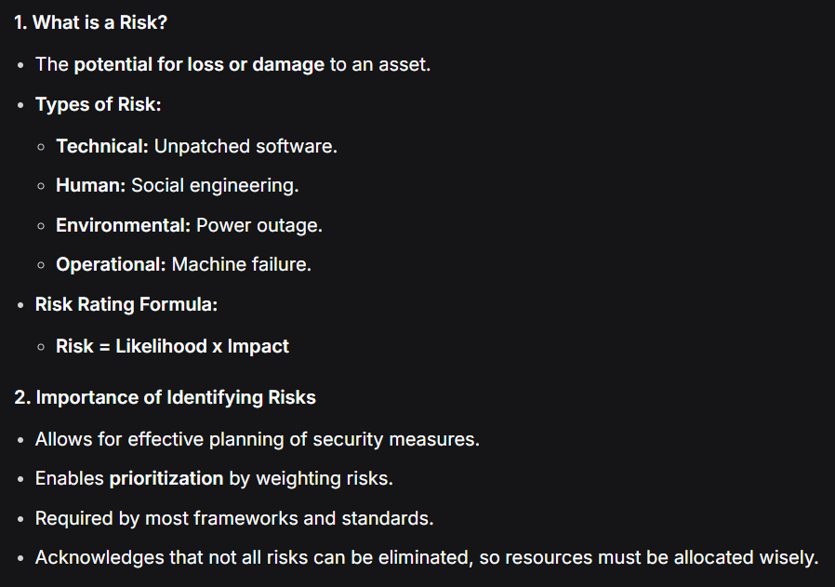

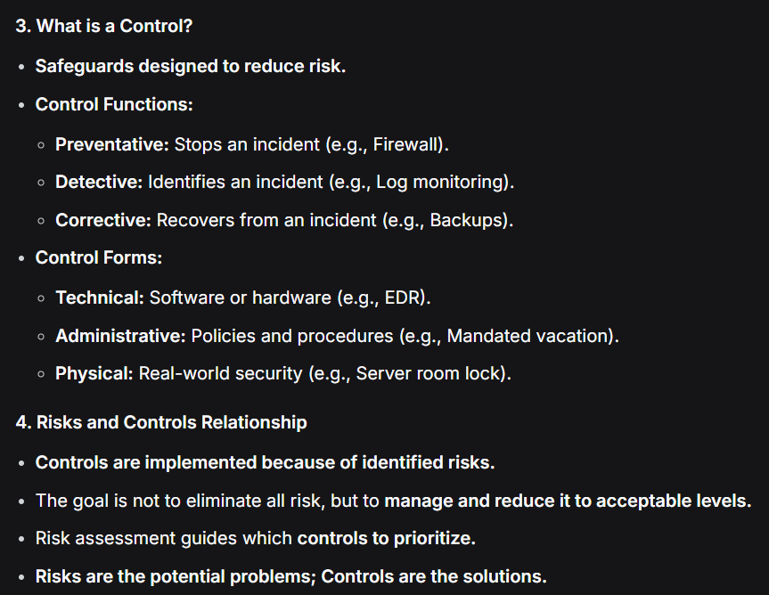

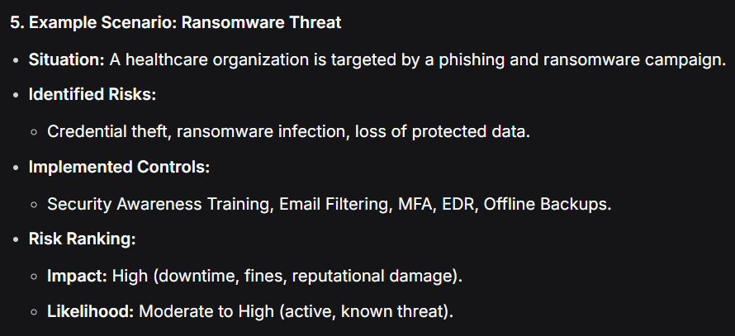

## Popular Security Frameworks

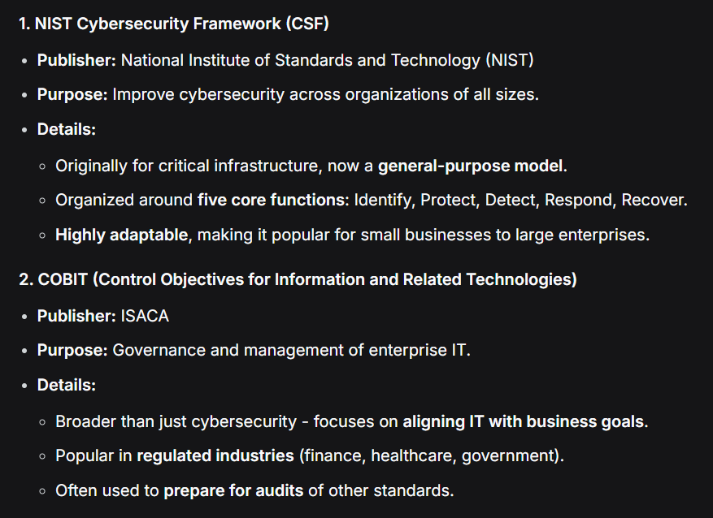

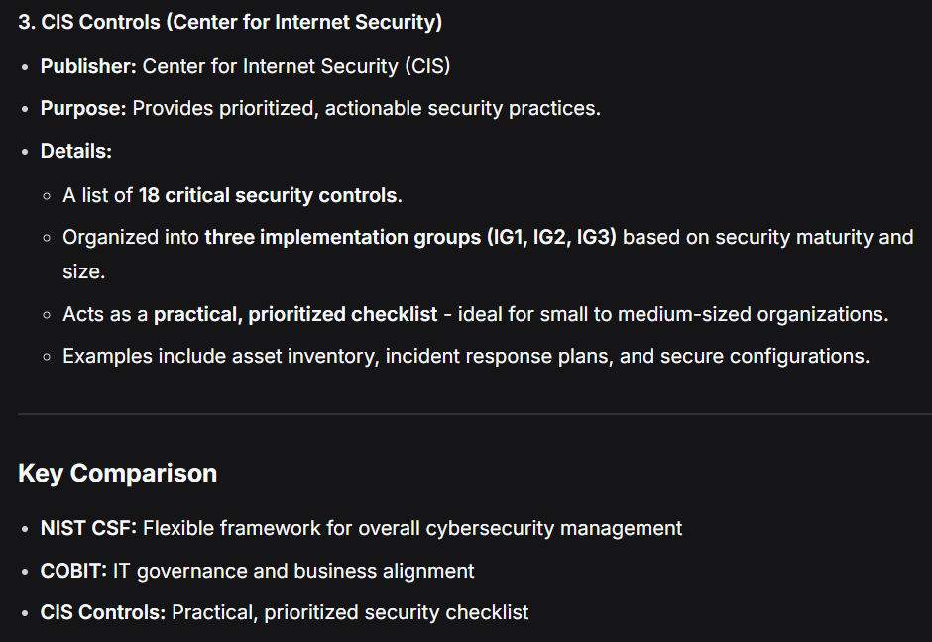

## Important Security Standards

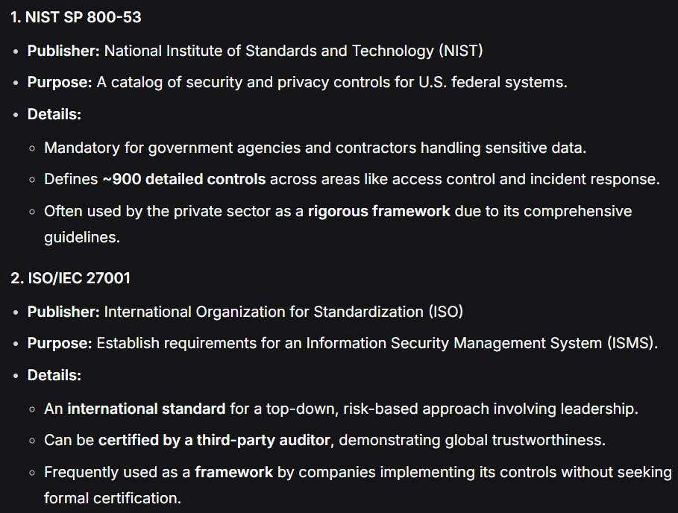

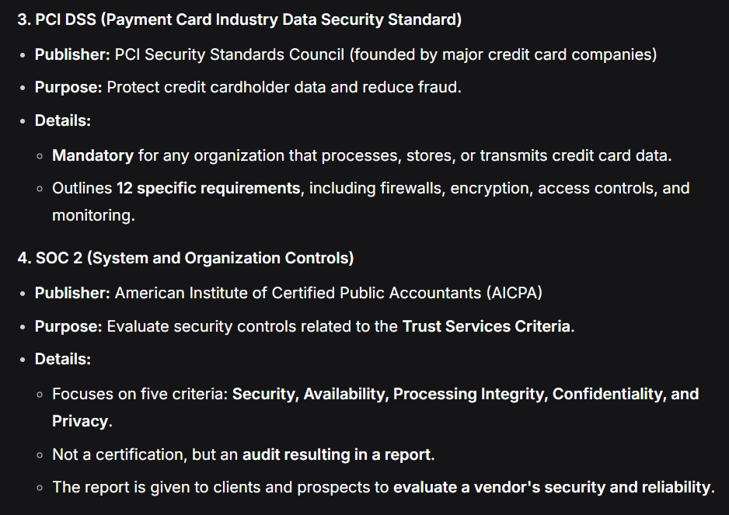

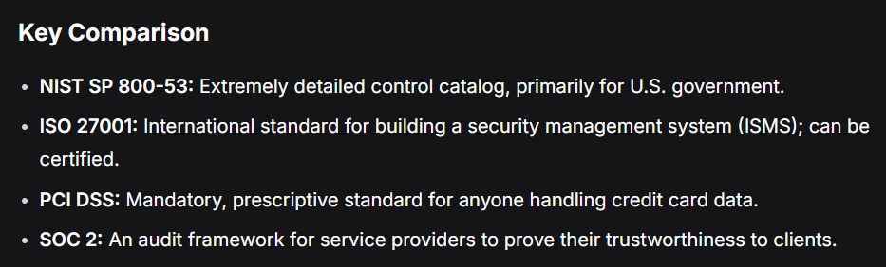

## Important Security Regulations

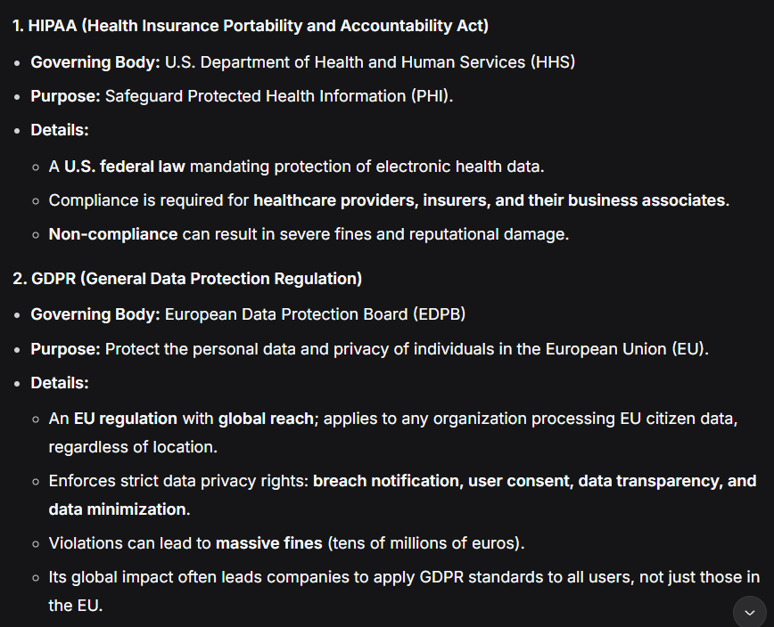

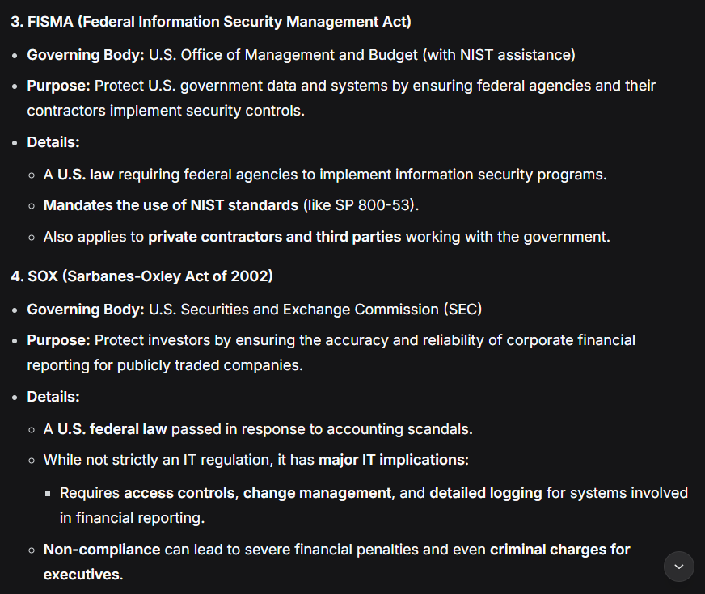

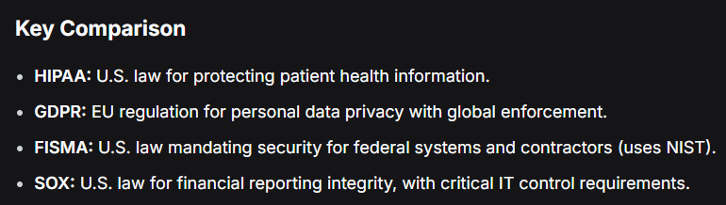

## GRC ( Governance Risk Compliance )

Integrated approach that orgs use to help align IT , security and business objectives in order to manage risks and meet regulatory requirements

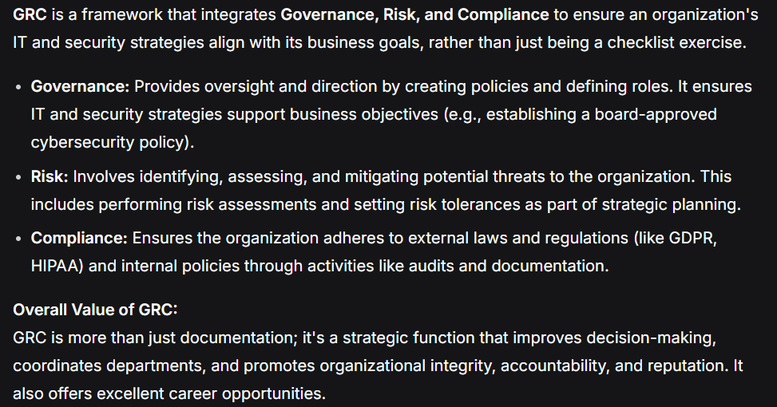

# Digital Forensics and Incident Response

## Breach

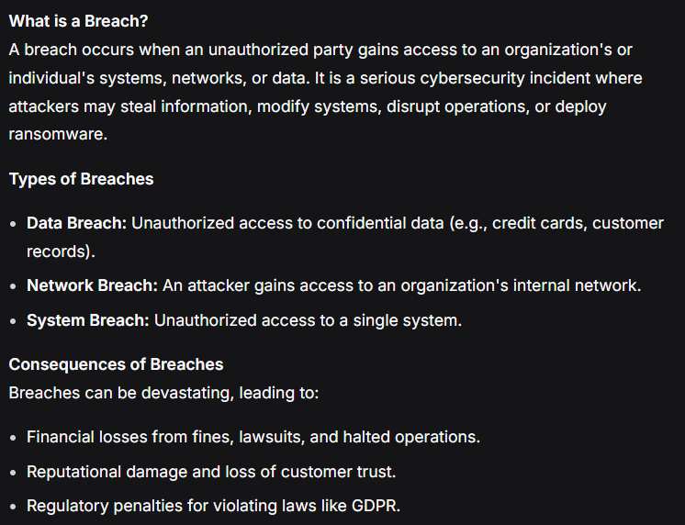

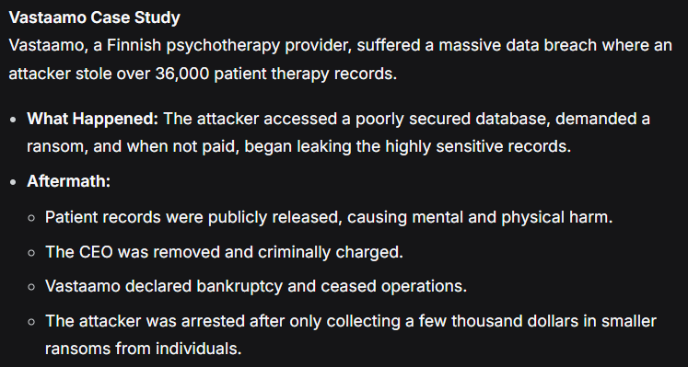

## Incident Response

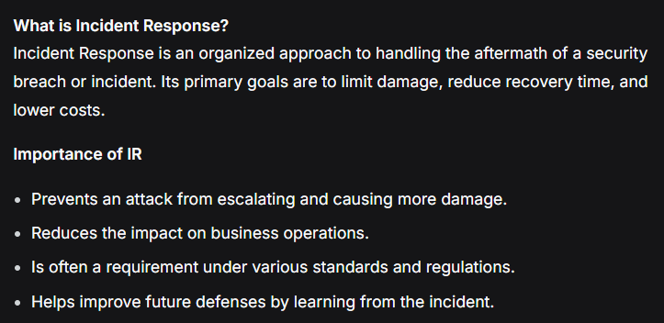

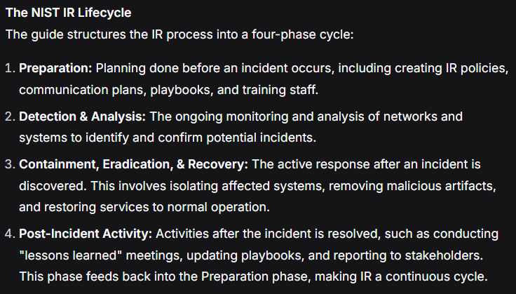

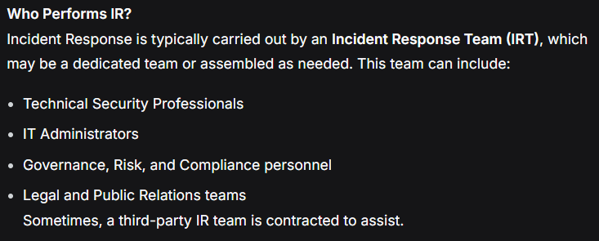

## Indicators of Compromise

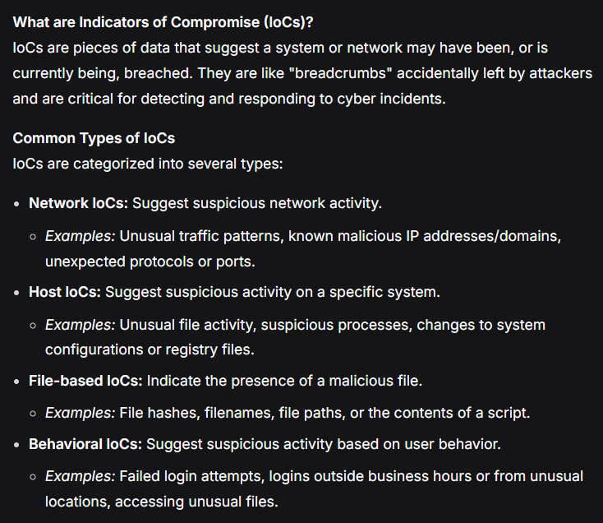

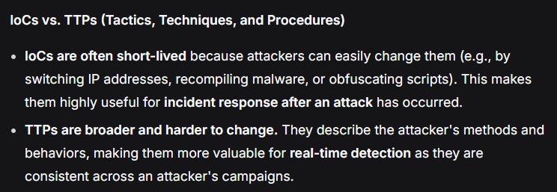

## Events v/s Incidents

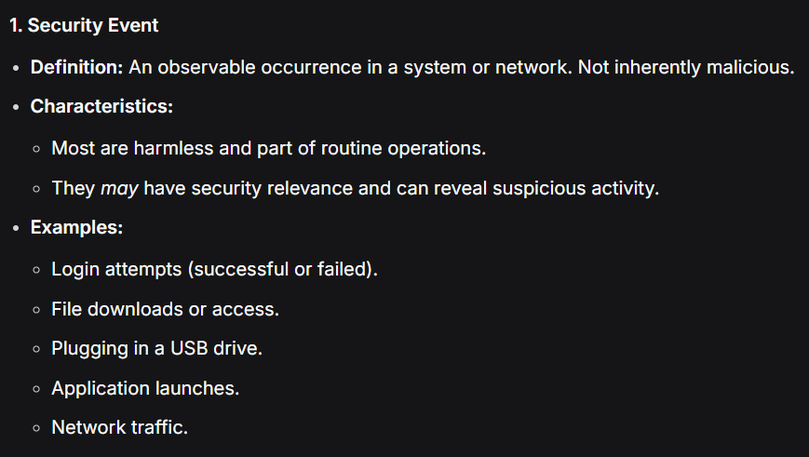

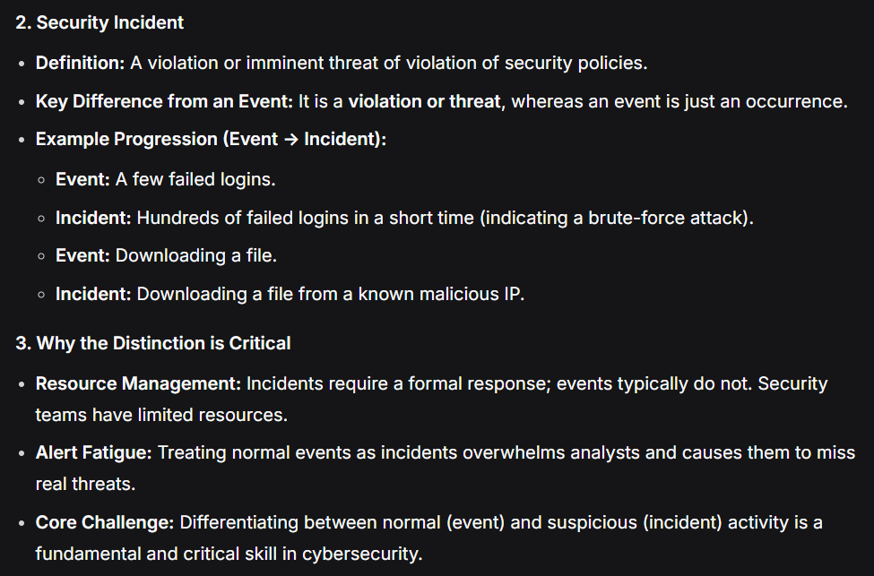

## Digital Forensics

